Precision Brain Tumor Classification: Harnessing Multi Class MRI Data for Accurate Diagnosis

Jaer Nizam, Jiazhen Lin, Alex Huang, Nouhad Rizk

# **Abstract**

# Timely and accurate diagnosis of brain tumors can significantly improve patient outcomes by providing doctors the tools needed to act quickly and precisely on treatment methods. Leveraging a comprehensive dataset of 3064 T1 weighted contrast MRI images encompassing meningioma, glioma, and pituitary tumors, this study addresses the critical issue of brain tumor detection and classification by deploying machine learning techniques to successfully distinguish between various types of brain tumors. The study aims to assess the effectiveness of several models, including a base CNN model fine-tuned with a range of optimizers such as ADAM, NADAM, RMSprop, and SGD, pre trained CNN models like VGG19, ResNet18, and InceptionV3, as well as unconventional models for image classification such as Random Forest Classifiers. The performance and the strengths and weaknesses of each model is reported using test statistics such as: F1-Score, Accuracy, and Log-Loss. Showcasing the power of convolutional neural networks, this study is able to yield state of the art performance in brain tumor classification from fine-tuned ResNet and VGG models. This research contributes and provides another perspective to the field of medical imaging and computer vision that can be utilized to help patients get expedited diagnoses, potentially leading to life changing effects through faster access to critical medical insights for brain tumor detection.

*Keywords: Convolutional Neural Network, Tumor Detection, Brain MRI images, Deep Learning*

**Introduction**

Brain tumors represent a significant and often life-threatening medical challenge, creating the need for accurate and timely diagnosis for effective treatment planning. Among the diverse array of brain tumors, meningiomas, gliomas, and pituitary tumors present unique diagnostic complexities due to their varying characteristics in terms of location, size, and imaging features. Magnetic Resonance Imaging (MRI) has emerged as a pivotal tool for visualizing these intricate structures with high soft tissue contrast. However, the reliable classification of these tumors based on MRI images remains a formidable task, requiring experienced professionals. Deep learning, particularly convolutional neural networks (CNNs), has exhibited remarkable potential in automating medical image analysis, offering a promising avenue for enhancing the precision and efficiency of brain tumor classification. There is a need for tailored deep learning models capable of accurately distinguishing between meningiomas, gliomas, and pituitary tumors. This research contributes to filling this gap by developing and evaluating multiple robust deep learning models for the automated classification of these brain tumors, aiming to significantly impact early diagnosis and subsequent treatment strategies for improved patient outcomes.

The approach of this experiment includes training various models on a dataset of different types of brain tumors to observe the outcomes and benefits of using each model. An in depth, side by side, analysis will be performed regarding the performance of each model. The analysis will be utilized to decide on the most promising model for brain tumor classification. Most of the models in this study will follow the CNN architecture, as many other works have proven the effectiveness of CNNs in various categories of image classification, including studies performed by Hashemzehi et al., Kang et al., Ren et al., and Gour et al. [1,2,3,4]. These experiments showcased the impressive ability of CNNs in classifying a variety of different types of images ranging from document classification to various medical imaging classification tasks. Along with the CNN architecture, this study will also showcase how CNNs compare in performance with the use of unconventional methods of image classification such as random forest classifiers. This paper delves into the potential of various models, including ResNet18, VGG19, InceptionV3, Base CNN, and Random Forest classifiers. Its aim is to pinpoint the most promising model for detecting brain tumors, acting as a pivotal step in accelerating the integration of deep learning within the realm of medicine.

**Related Work**

Numerous studies have highlighted the transformative impact of deep learning in streamlining functionalities across diverse fields. Gour et al.'s exploration of breast cancer classification using CNN models, Kang et al.'s application of CNNs for document classification, and Ren et al.'s investigation into forensic image classification employing XGBoosts and CNNs collectively underscore the immense potential of deep learning across various domains[1,3,4]. These works not only demonstrate the promising capabilities of deep learning but also reinforce the credibility of Convolutional Neural Networks (CNNs), a pivotal focus in this study.

Several studies closely align with the focus of this paper. In the investigation conducted by Hashemzehi et al., the researchers employed the identical "3064 T1-weighted contrast" brain tumor MRI images to train a CNN model. Their findings showcased the development of a proficient CNN model that achieved remarkable performance, boasting an accuracy of 95%[2]. In a parallel effort, Das et al. conducted experiments on the same dataset, aiming to develop a classifier that could significantly assist radiologists in brain tumor classification. Their efforts yielded success, resulting in a CNN model utilizing the ADAM optimizer with a classification accuracy of 94%. Notably, they asserted that their model exhibited superior generalization compared to previous models[5].

In a noteworthy study, Chatterjee et al. delved into the efficacy of a specialized ResNet model designed for the specific task of identifying the presence of brain tumors in diverse MRI images. Diverging from the goals of both prior research and the current paper, Chatterjee et al. concentrated on developing a model with the capability to distinguish between MRI images containing and lacking brain tumors. Their efforts culminated in the creation of a ResNet model boasting an impressive 97% accuracy in detecting brain tumors[6].

# **Proposed Methods**

In pursuit of identifying the optimal classifier for brain tumor images, the training of various machine learning models was performed. These encompassed a CNN model built from scratch, pre-trained CNN models, namely ResNet18, InceptionV3, and VGG19, as well as a Random Forest Classifier. To comprehensively assess model performance, all CNN models were trained using four distinct optimizers: SGD, Adam, NAdam, and RMSProp. Additionally, the study involved a comparative analysis of performance across the different optimizers employed, using metrics such as accuracy, f1-score, and log-loss.

**Convolutional Neural Networks**

Convolutional Neural Networks (CNNs) were employed as a cornerstone for addressing the intricate task of brain tumor image classification. CNNs are specialized neural networks designed for processing structured grid data, making them particularly well-suited for image analysis. The architecture of the CNN models in this study comprises multiple convolutional layers, each incorporating Rectified Linear Unit (ReLU) activation functions to introduce non-linearity and capture intricate image features effectively. Additionally, max-pooling layers were incorporated to downsample spatial dimensions and reduce computational complexity. The training procedure involved iterative optimization through backpropagation, adjusting model parameters to minimize the chosen loss function. To enhance model generalization, various regularization techniques such as dropout layers. Hyperparameters, including learning rates, batch sizes, and the number of epochs, were carefully tuned to optimize model performance.

Generalized CNN Model Diagram [7]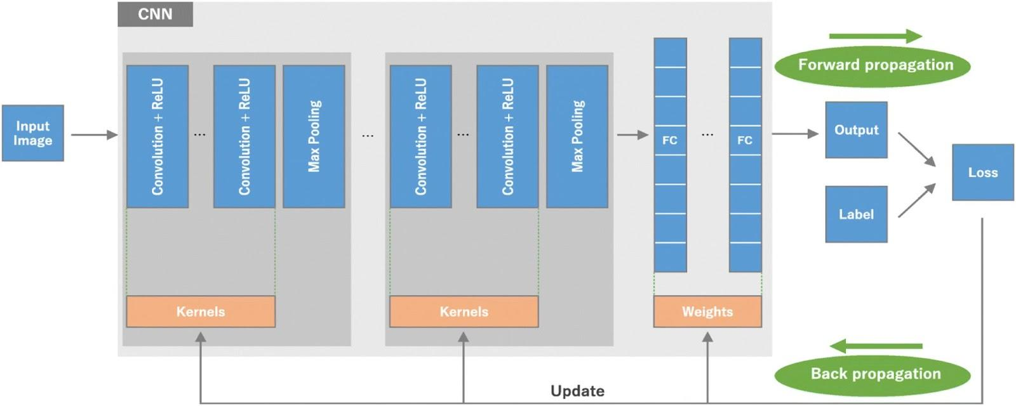

**ResNet18**

The ResNet18 architecture adheres to the design principles of CNN models, featuring a total of 16 convolutional layers that are systematically organized into residual blocks. Each residual block follows a well-defined sequence of operations, fostering efficient learning in deep neural networks. The incorporation of batch normalization plays a crucial role in stabilizing activations during training, contributing to enhanced model robustness. Consistent with the base CNN architecture, ResNet18 relies on Rectified Linear Unit (ReLU) activation for introducing non-linearity. The distinctive residual block structure of ResNet18 not only addresses the vanishing gradient problem but also significantly contributes to the model's strength in image classification tasks. Pretrained on the extensive ImageNet dataset, comprising millions of diverse images, this model's architecture and generalization capabilities makes it a flexible model to fine-tuning on specific datasets such as the brain tumor dataset.

**VGG19**

The VGG19 architecture, akin to the ResNet18 model, adheres to the convolutional neural network (CNN) architecture but distinguishes itself with its unique structure. VGG19 comprises a total of 19 layers, all convolutional with ReLU activation, organized into blocks of stacked convolutional layers. This design choice allows for a deeper network, capturing intricate hierarchical features in images. This architecture, trained on the same ImageNet dataset as ResNet18, has demonstrated effectiveness in image classification tasks.

**InceptionV3**

The InceptionV3 model distinguishes itself from normal CNNs by introducing the concept of inception modules to enhance the network's ability to capture diverse features. Comprising 48 layers, InceptionV3 features a series of these inception modules, each incorporating multiple parallel convolutional operations with different kernel sizes. This unique design allows the model to simultaneously capture features at various scales. This model also utilized techniques such as batch normalization and ReLU activation for more stability and non-linearity. As with the other pretrained models, the InceptionV3 is trained on the expansive

ImageNet dataset.

**Random Forest Classifier**

The Random Forest Classifier employs ensemble learning, combining predictions from multiple decision trees for improved accuracy. Each tree is built on a subset of the data and features, introducing randomness to enhance performance and mitigate overfitting. Known for its versatility and robustness, Random Forest is widely used for classification tasks, demonstrating effectiveness in handling complex relationships and resisting overfitting.

InceptionV3 Architecture [8]

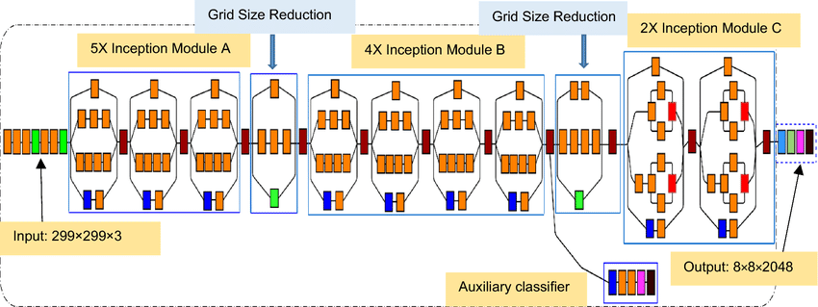

# Experiments

**Dataset**

The dataset consists of 3064 T1 weighted contrast MRI Images with 708 Meningioma tumors, 1426 Glioma tumors, and 930 Pituitary tumors[9]. 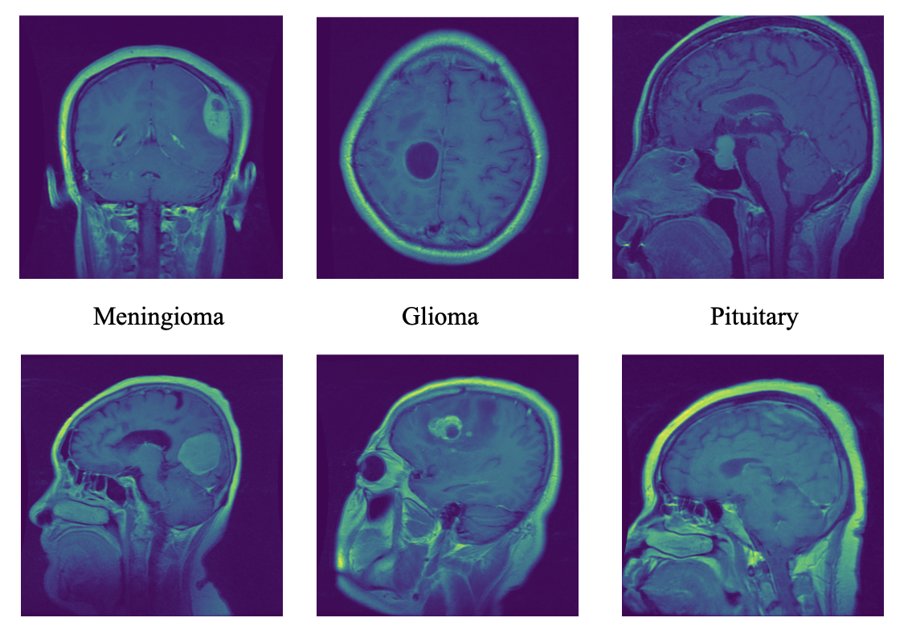

The images were separated into a 80/20 training and testing split, to be used for fine-tuning and evaluating the models. The image preprocessing is personalized for all models, with all images being normalized and resized to adhere to the parameters of every model. Images were sized to 224 x 224 for the base CNN, ResNet and VGG models, and 299 x 299 for the InceptionV3 model.

## **Base Convolutional Neural Network**

Multiple CNN models were created and trained using various optimizers: Stochastic Gradient Descent, ADAM, NADAM, and RMSProp. Each optimizer had different learning rates and momentum used as parameters. The learning rates used are: 0.2, 0.1, 0.05, 0.005, 0.002, and 0.001. The momentums were only used for SGD and RMSprop and they are: 0.9, 0.7, 0.5, 0.2, 0.1, and 0. This totals to 84 models. To save time, these models were run with only 3 epochs. Models were selected for each optimizer based on the accuracy and loss, then ran for 10 epochs. The models were also trained and compared when all the optimizers have the same parameters and a few combinations were chosen randomly.

## Pretrained Models

The pretrained models tried in this study include: ResNet18, VGG19, and InceptionV3. All of these CNNs are trained on over a million images and consist of many convolutional layers for a deeper feature extraction. Four instances of each pretrained model were fine-tuned and evaluated with the goal of comparing the performance between the different optimizers: Stochastic Gradient Descent, ADAM, NADAM, and RMSProp.

## Random Forest Classifier

In the pursuit of an optimal classification model, the study also delved into the application of a Random Forest Classifier. To facilitate this exploration, the desired shape for the data was found The preprocessing pipeline for the Random Forest Classifier included steps such as image transformation which included steps such as rescaling, pixel normalization and converting image sizes. These steps were aimed towards optimizing the input data for the model in order to enhance its ability to discern patterns and make accurate predictions.

All models are evaluated with 3 different metrics: Accuracy, F1-Score, and Log-Loss.

# 

# Results and Discussion

The following results are the testing accuracies from base CNN models: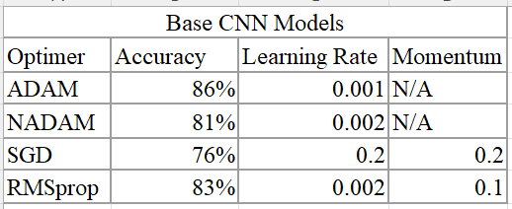

The table below shows the top 6 models with the best performance when classifying different brain tumors from 613 images from the testing set. Overall, the pretrained models yielded the best performance, as the top 3 models are ResNet and VGG models. The ResNet18 model with an SGD optimizer outperformed all other models, with the highest accuracy and f1-score, along with the lowest log-loss. The fine-tuned ResNet18 model yielded state of the art results which has potential to be a viable tool in the health industry for brain tumor classification.

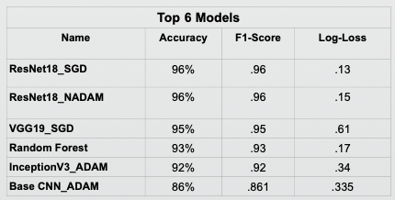

Given the results, SGD appears to be the best optimizer. In the CNN models, changing the parameters of the SGD optimizer yielded the greatest amount of change in accuracy. With more epochs and fine tuning, the SGD results of the base CNN model could have a higher accuracy than the ADAM optimizer. The downside to this research is that the MRI images used were taken from different angles. Although there are some from the same angle, a majority of the Meningioma tumors are from the back view, most of the glioma tumors are from a top view, and the pituitary tumors are from the side view. The models run a risk of learning the shape of the head and not the tumor. A dataset with all three points of view could get results that are more in line with how MRIs are used to differentiate tumors.

Taking a deeper look at this studies best performing model, the ResNet18 with SGD:

| **Class** | **Precision** | **Recall** | **F1-Score** |
| --- | --- | --- | --- |
| Meningioma | 92.85% | 89.61% | .9112 |
| Glioma | 96.88% | 100% | .9829 |
| Pituitary | 96.34% | 97.51% | .9660 |

The model performed the best in identifying cases of Glioma, and had the weakest performance in identifying Meningioma. This can most likely be explained due to the imbalance of classes in the dataset.

# Conclusion

This study illuminates the transformative potential of deep learning in the realm of medical image classification, specifically addressing the complex challenge of distinguishing between meningiomas, gliomas, and pituitary tumors in brain imaging. The exceptional performance of the fine-tuned ResNet18 model holds promise as an invaluable tool for medical professionals engaged in the diagnostic process. Alongside the rapidly growing field of deep learning and AI, this research stands as a testament to the transformative power of these cutting-edge tools, propelling us into a future where technological advancements seamlessly intertwine with the medical diagnosis process.

## Future Work

Looking ahead, our future endeavors encompass extending the applicability of the findings from this study by testing them on more diverse datasets and various medical imaging scenarios. This exploration promises to broaden the scope of applications for these models within the medical field. Additionally, our sights are set on achieving deeper fine-tuning, recognizing that limited resources constrained the extent of model tuning across a large number of epochs in the current study. With the prospect of more extensive data and increased epochs, there exists untapped potential for these models to attain even higher levels of performance, reinforcing their effectiveness in advancing the field of medical image classification.

# References

1. Gour, M., Jain, S., & Sunil Kumar, T. (2020). Residual learning based CNN for breast cancer histopathological image classification. International Journal of Imaging Systems and Technology, 30(3), 621-635.
2. Hashemzehi, R., Mahdavi, S. J. S., Kheirabadi, M., & Kamel, S. R. (2020). Detection of brain tumors from MRI images base on deep learning using hybrid model CNN and NADE. biocybernetics and biomedical engineering, 40(3), 1225-1232.
3. Kang, L., Kumar, J., Ye, P., Li, Y., & Doermann, D. (2014, August). Convolutional neural networks for document image classification. In 2014 22nd international conference on pattern recognition (pp. 3168-3172). IEEE.
4. Ren, X., Guo, H., Li, S., Wang, S., & Li, J. (2017). A novel image classification method with CNN-XGBoost model. In Digital Forensics and Watermarking: 16th International Workshop, IWDW 2017, Magdeburg, Germany, August 23-25, 2017, Proceedings 16 (pp. 378-390). Springer International Publishing.
5. S. Das, O. F. M. R. R. Aranya and N. N. Labiba, "Brain Tumor Classification Using Convolutional Neural Network," 2019 1st International Conference on Advances in Science, Engineering and Robotics Technology (ICASERT), Dhaka, Bangladesh, 2019, pp. 1-5, doi: 10.1109/ICASERT.2019.8934603.
6. Chatterjee S, Nizamani FA, Nürnberger A, Speck O. Classification of brain tumours in MR images using deep spatiospatial models. Sci Rep. 2022 Jan 27;12(1):1505. doi: 10.1038/s41598-022-05572-6. PMID: 35087174; PMCID: PMC8795458.
7. Yamashita, R., Nishio, M., Do, R.K.G. *et al.* Convolutional neural networks: an overview and application in radiology. *Insights Imaging* 9, 611–629 (2018). <https://doi.org/10.1007/s13244-018-0639-9>
8. Singh, Dr & Vishwakarma, Dinesh. (2021). A deeply coupled ConvNet for human activity recognition using dynamic and RGB images. Neural Computing and Applications. 33. 10.1007/s00521-020-05018-y.
9. Cheng, Jun (2017). brain tumor dataset. figshare. Dataset. <https://doi.org/10.6084/m9.figshare.1512427.v5>

# Contributions

Jaer Nizam did the preprocessing for the data and worked on the pre-trained CNN models. Jiazhen Lin found the dataset and constructed and trained the base CNN model. Alex Huang made the random forest model and assisted with optimizing performance of the models.